Adam Mohmoud
AZ-900 Fundamentals
Manage Resource Locks Lab
Mohmoud.adam@gmail.com

In this lab I was managing resource locks in Azure which involves setting restrictions on critical resources to prevent accidental deletion or modifications, ensuring the stability and compliance of the infrastructure.

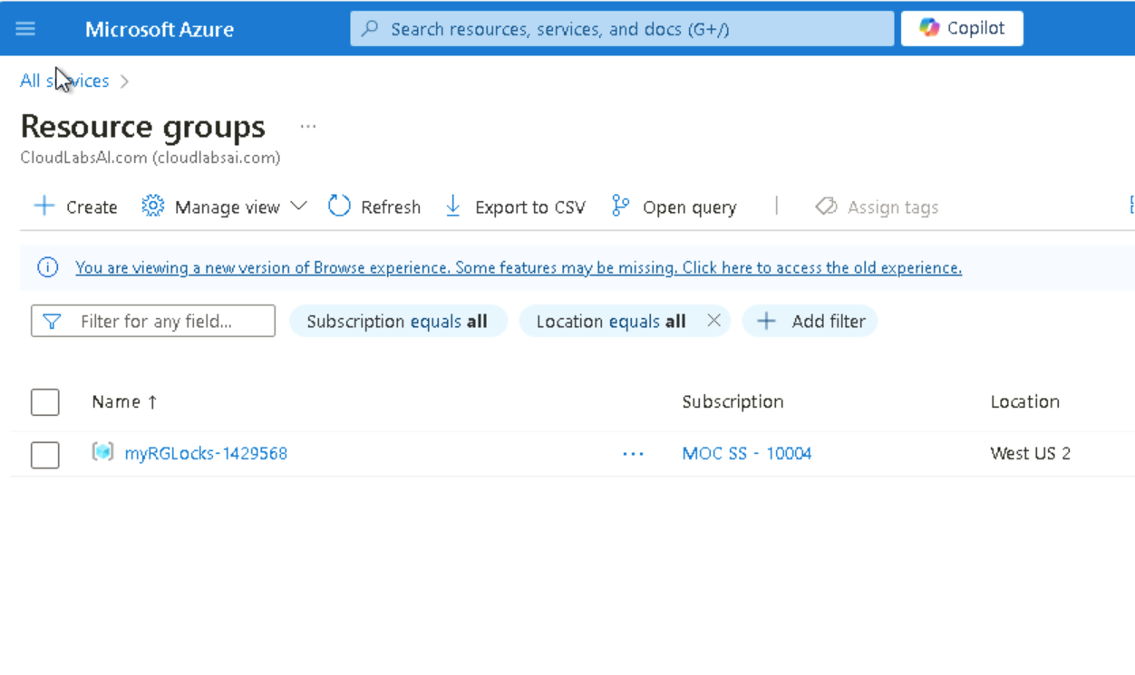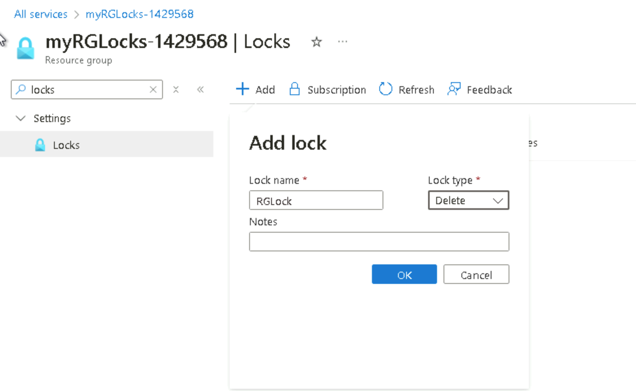
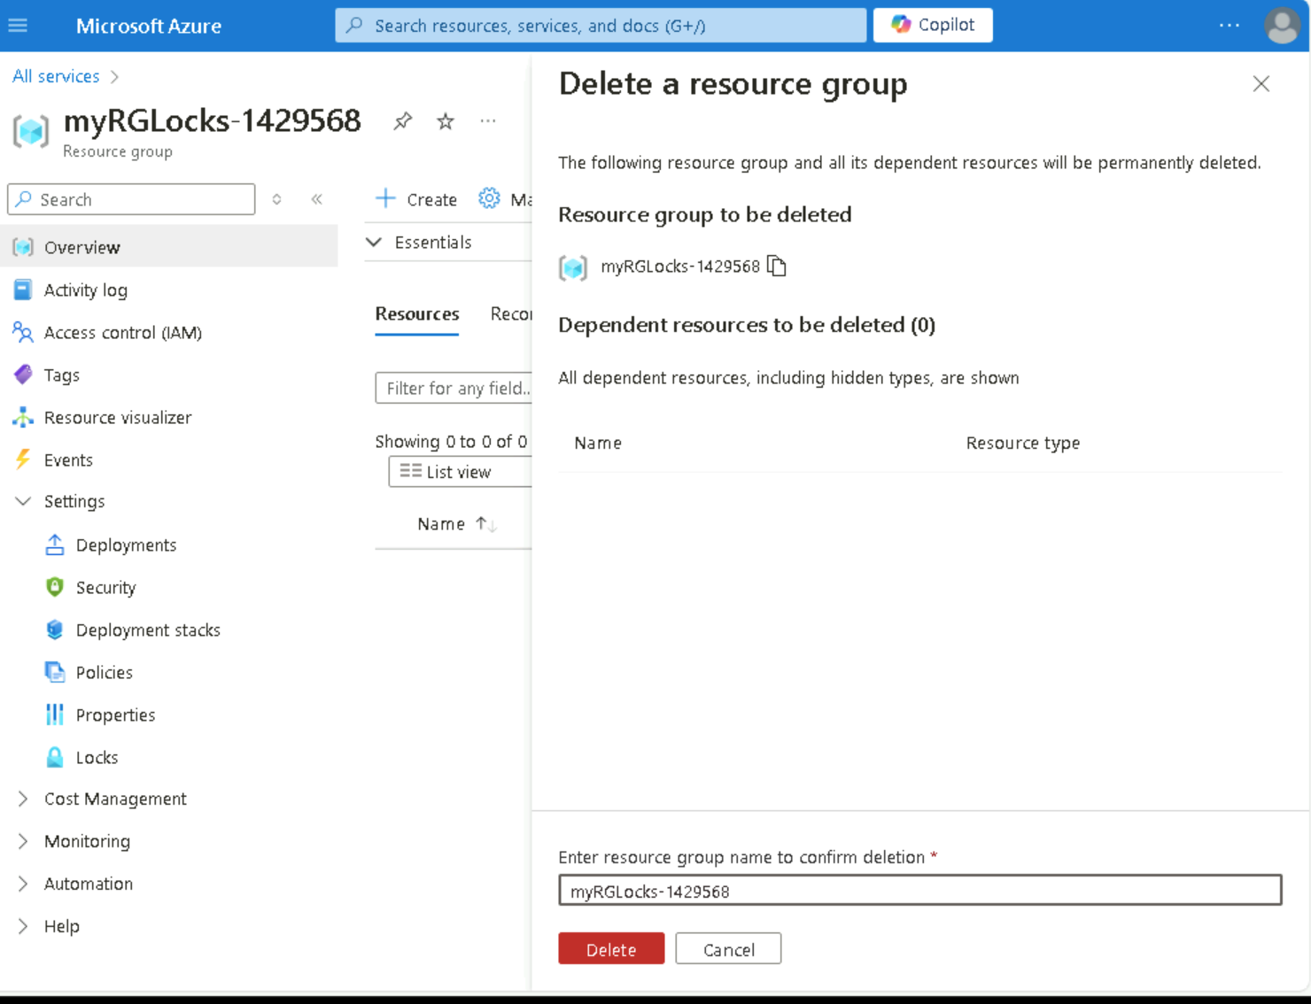
On myRGLocks-1429568 blade, I clicked ‘delete resource group’, copy the Resource Group name, and paste it into the ‘Enter resource group name to confirm deletion’ and click delete. I will receive an error message stating the resource group is locked and can't be deleted.

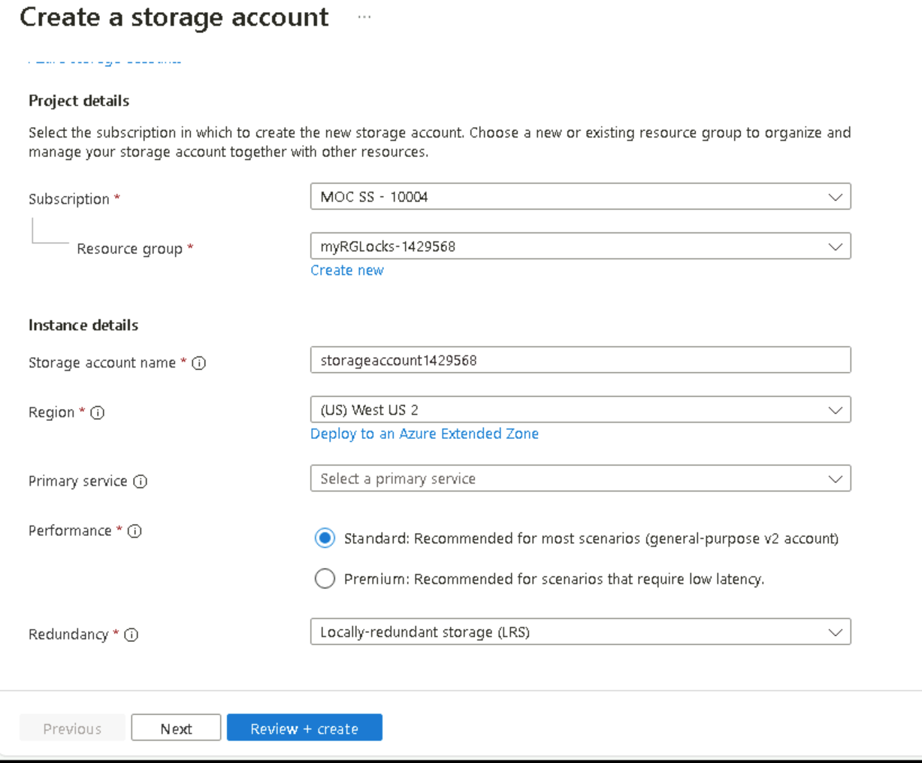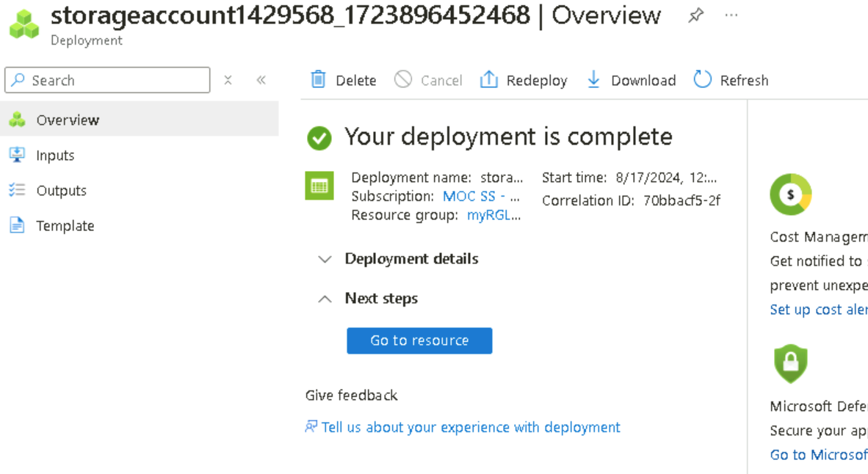
I proceeded with creating and validating a storage account.

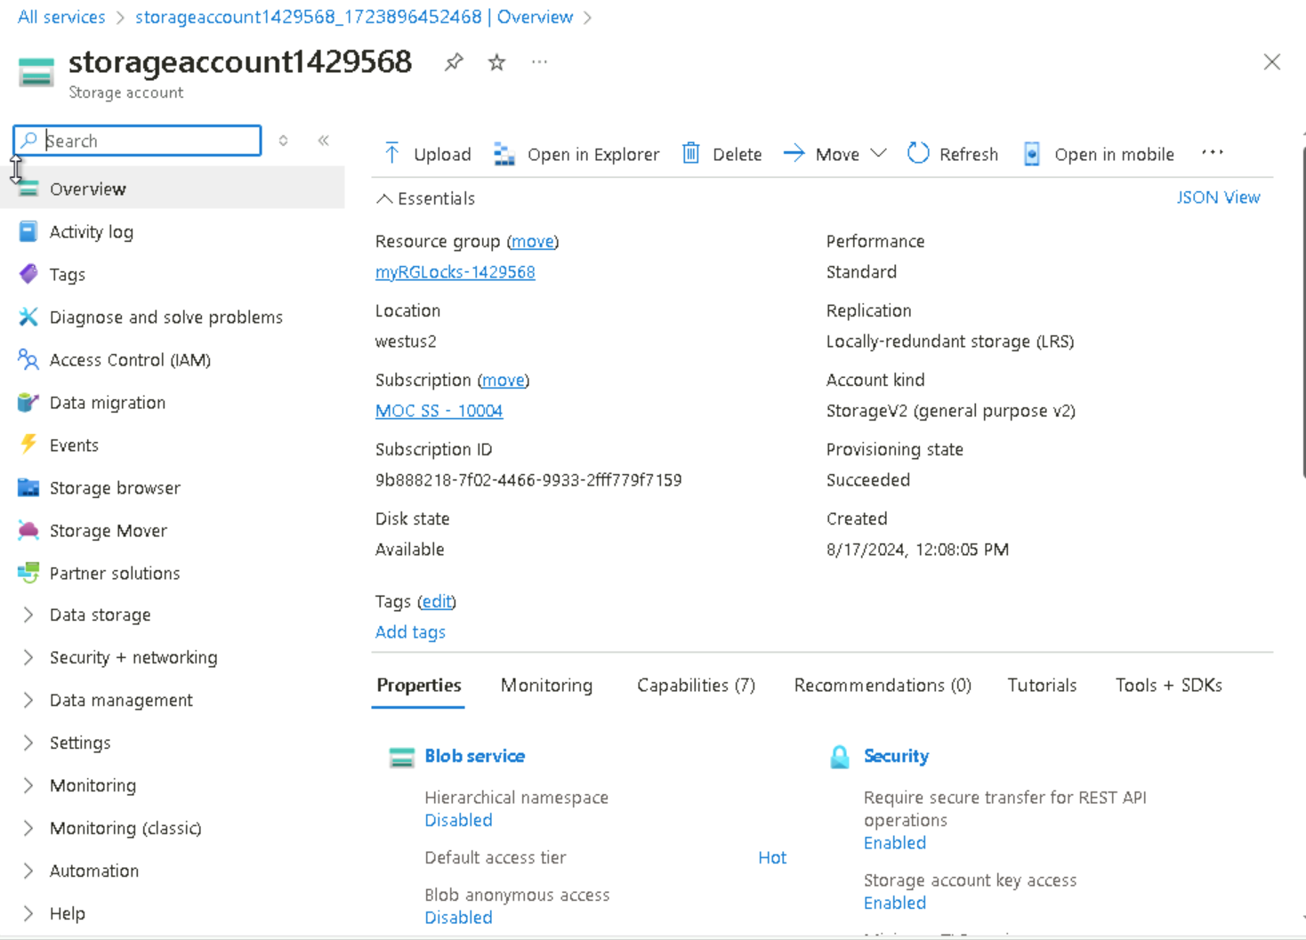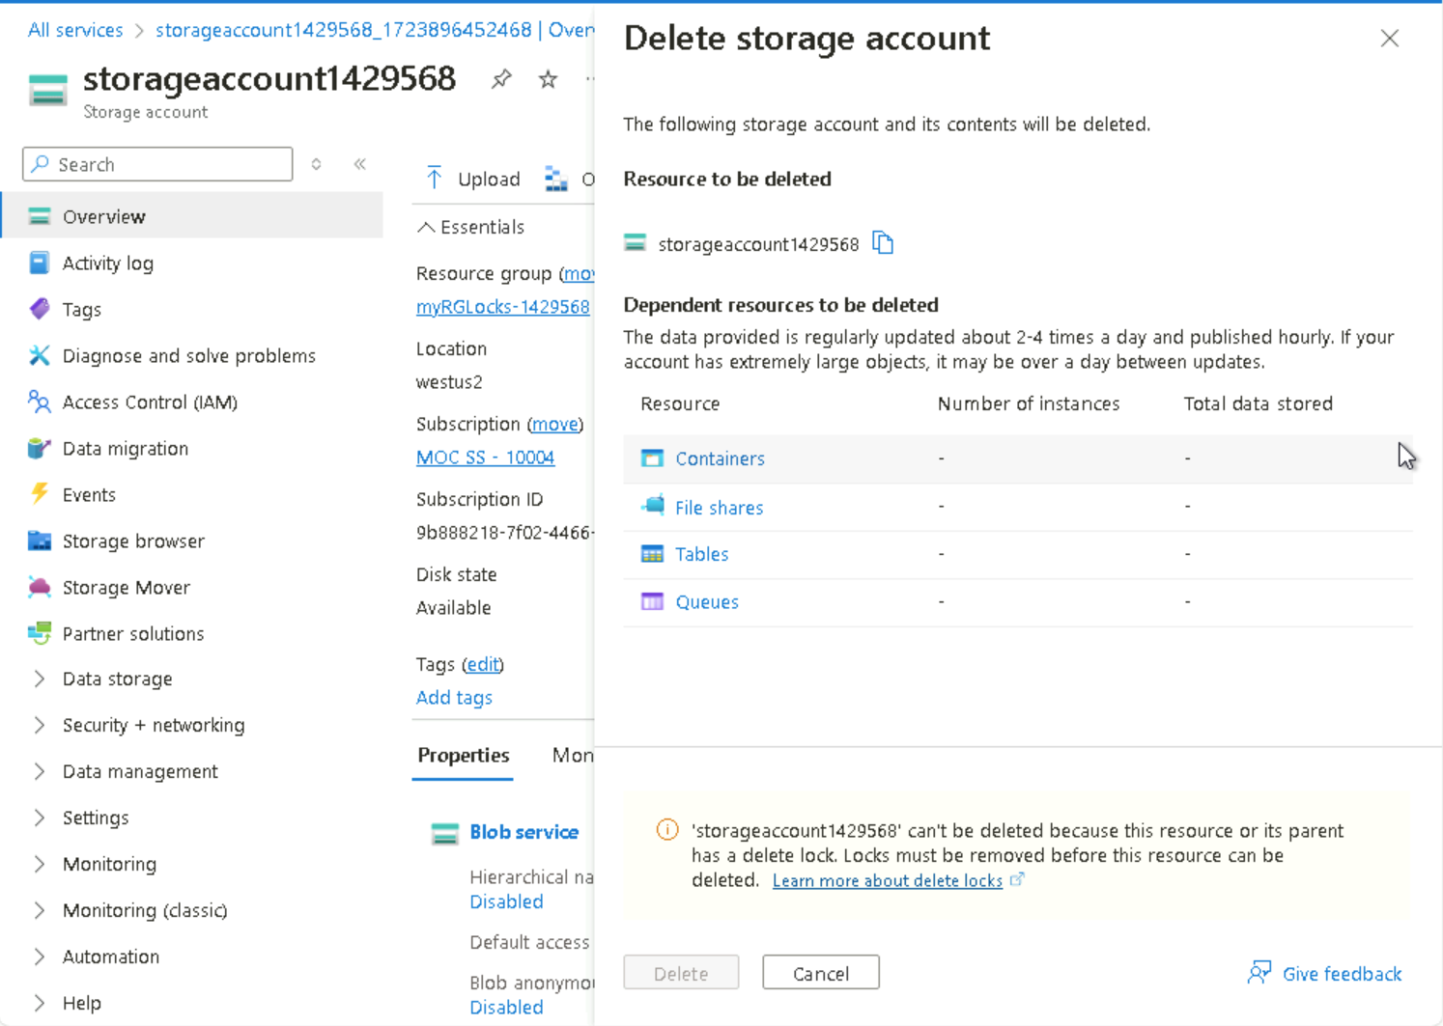
From the Overview panel of the newly created storage account, I clicked delete and took notice of an error message stating the resource or its parent has a ‘delete lock’.
Although I did not create a lock specifically for the storage account, I did create a lock at the resource group level, which contains the storage account. As such, this parent level lock prevents me from deleting the resource and the storage account inherits the lock from the parent.
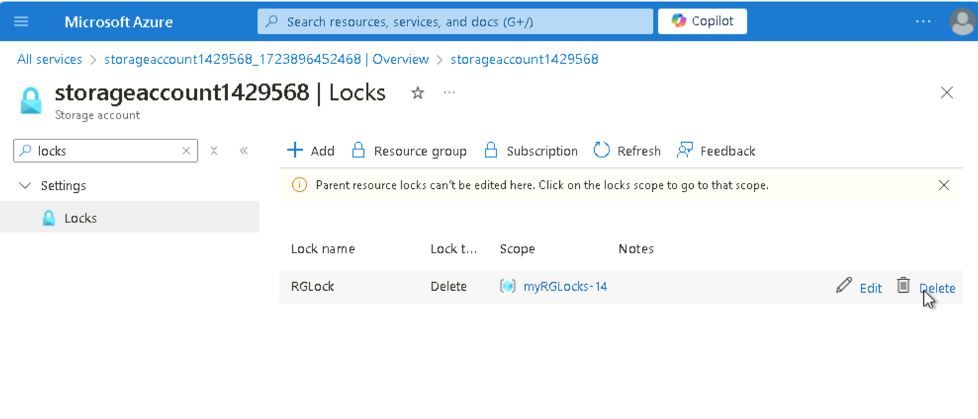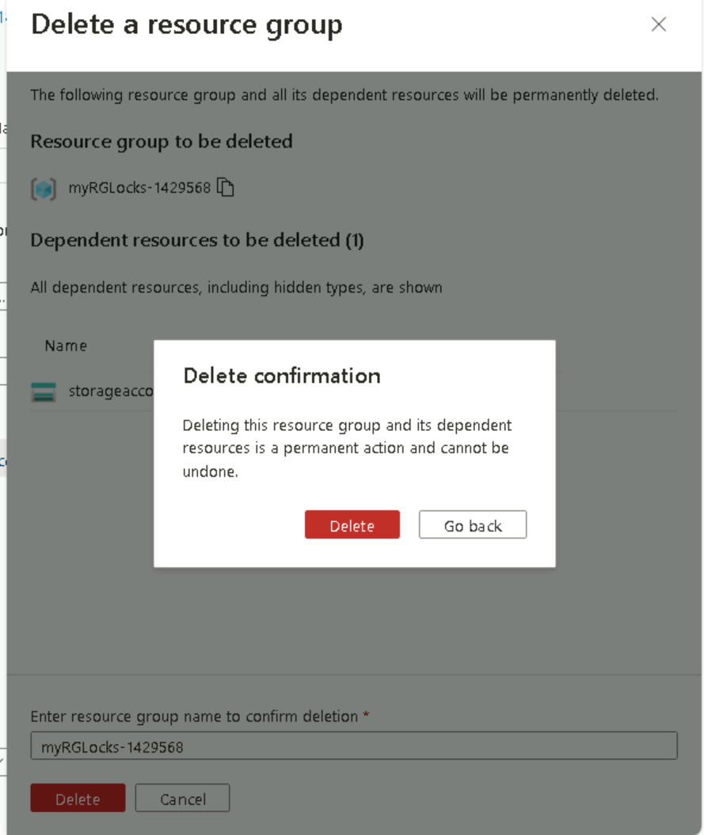
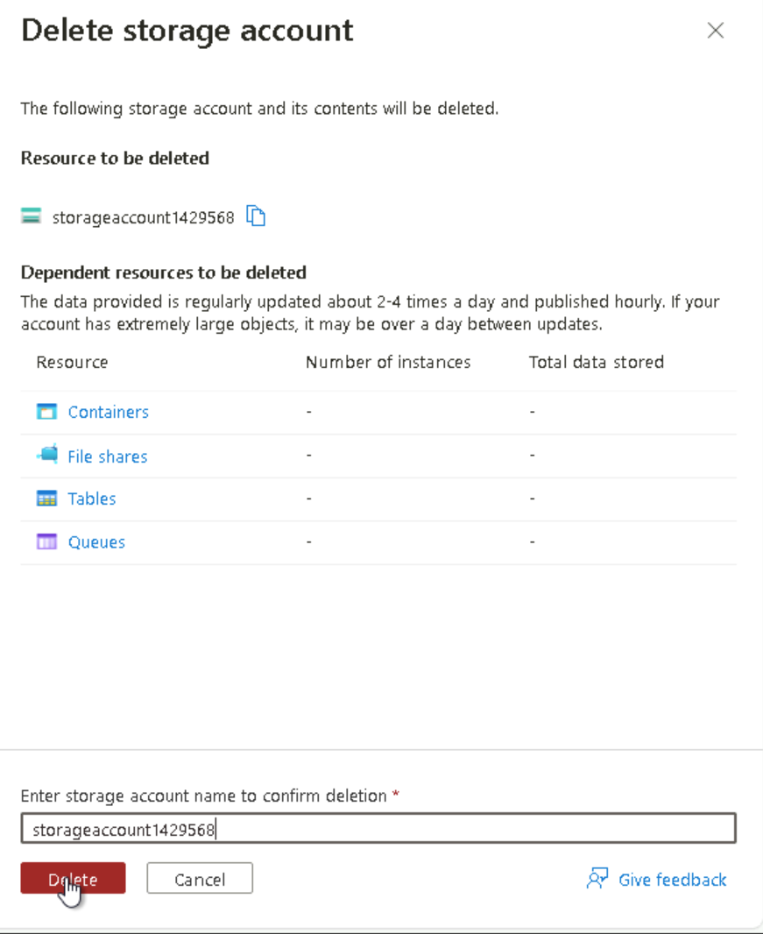
Return to the myRGLocks-1429568 resource group blade and, in the Settings list clicked ‘Locks’ and then the ‘Delete’ link to the right of the RGLock entry.
From the myRGLocks-1429568, from the Overview list I clicked storageaccount1429568 storage account. On the storage accounts blade, I selected to delete (1) copy the stoarge account (2) name and paste in Enter storage account name to confirm deletion field, then (3) click delete on confirmation window.


